

Department of Electronics and Computers
Study programme: Applied Electronics

Verification Project
Apartment Boiler Control

Table of Contents

1 The Digital Design of the Circuit. 3
1.1 Block Diagram 3
1.2 General Functionality Description of the Dut 3
1.3 Dut Interfaces 4
1.4 List of DUT Functionalities 5
1.5 Waveforms 6
1.6 Register Table 7
2. Verification of the Digital Circuit Design 8
2.1 Verification Environment Architecture 8
2.1.1 Driver for Button Interface 8
2.1.2 APB Driver 8
2.1.3 Output Interface Monitor 8
2.1.4 APB Interface Transaction 8
2.1.5 Output Interface Transaction 8
2.2 Functional Coverage Elements 9
2.3 Tests 9
2.4 Obtained Results 10

The Digital Design of the Circuit.
• Block Diagram
• General Functionality Description of the DUT
• DUT Interfaces
• List of DUT Functionalities
• Schematic Diagram
• Waveforms
• Register Table

1.1 Block Diagram
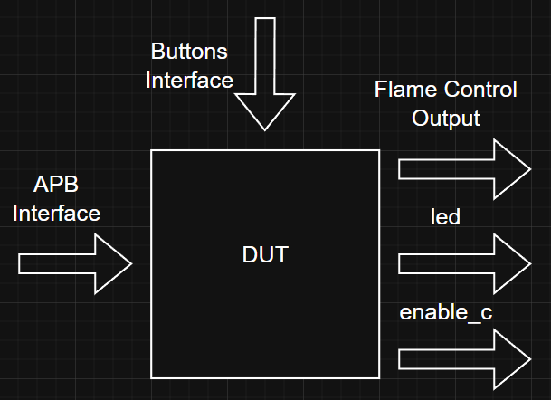

Figure 1. DUT - Apartment Boiler Control

General Functionality Description of the Dut
The DUT enables control over an apartment boiler, specifically for igniting the flame and maintaining it for a well-defined period, depending on the boiler’s configuration. The functionalities of the boiler are restricted by the manufacturer, while its usage is entirely dependent on the user.

Dut Interfaces
Table 1. Signals in the Configuration Interface – APB
Data Transmission Interface
Signal Name | Bit Width | Direction | Description
pclk | 1 | Input | Synchronization signal
paddr | 2 | Input | Address being accessed
pwrite | 1 | Input | Indicates write when HIGH and read when LOW
psel | 1 | Input | Slave device selection
penable | 1 | Input | Indicates the next transfer cycles
pwdata | 8 | Input | Contains the data to be written
pready | 1 | Output | Acknowledgment signal
prdata | 8 | Output | Contains the data to be read

Table 2. Signals in the Button Interface
Configuration Interface
Signal Name | Bit Width | Direction | Description
button_mod_econ | 1 | Input | Selects economy mode
button_mod_comf | 1 | Input | Selects comfort mode
button_mod_thermo | 1 | Input | Selects thermostat mode
button_child_prot | 1 | Input | Selects child protection mode

Table 3. Output Interface Signals
Result Display Interface
flame | 1 | Output | Ignition signal
led | 1 | Output | Power indicator — active in all states except s0
enable_c | 1 | Output | Counter enable — active only in econ and comf states

List of DUT Functionalities
- The system can be turned on/off via a button.
- After shutting down, the system resets on startup, beginning operation from state s1.
- A register in the DUT can be programmed to activate functionalities (e.g., econ/comf) via an APB interface.
- The DUT allows selecting one of the modes using buttons through a button interface.
- The DUT controls the duration for which the flame remains lit, depending on the selected mode.
- An LED indicates the boiler's power status.
- Provides an economy mode option.
- Provides a comfort mode option.
- Child protection mode can be activated, preventing other buttons from functioning.
The DUT starts in the mode selection state, s1. Assuming register 0x00 is configured as 1111, enabling all DUT functionalities, button presses are checked. If the economy mode button is pressed, the DUT transitions to the state handling economy mode functionalities. Pressing any other mode button will deactivate the logical 1 state of the economy mode button and activate a different functional mode.
For example, if the DUT is in economy mode and the comfort mode button is pressed, the system transitions to comfort mode. Pressing buttons while another mode is active will switch the system from one state to another. If the child protection mode button is pressed, all other buttons will be disabled until the protection button is set to logical 0.
Handling each functional state involves maintaining the flame for a specific duration, which corresponds to a certain number of clock cycles.
Other DUT Signals
- counter – Internal signal, represents a counter used to maintain the "flame" signal for a specific number of clock cycles.
- enable_c – Output signal, used to activate the counter.
- data_in – Internal signal, used for loading data into the counter.
- finish – Internal signal, indicates the completion of the counter's counting process.
Encountered Issues:
Using a register (func_reg) to limit DUT operation by restricting access to its states. This was implemented using a logical AND check on the corresponding bit from func_reg for each state.Implementing the child protection function (button press protection) – Similar to functionality restriction, an AND check is used when transitioning between states. child_protection must be set to logical 0 to allow state transitions via button presses.

Waveforms

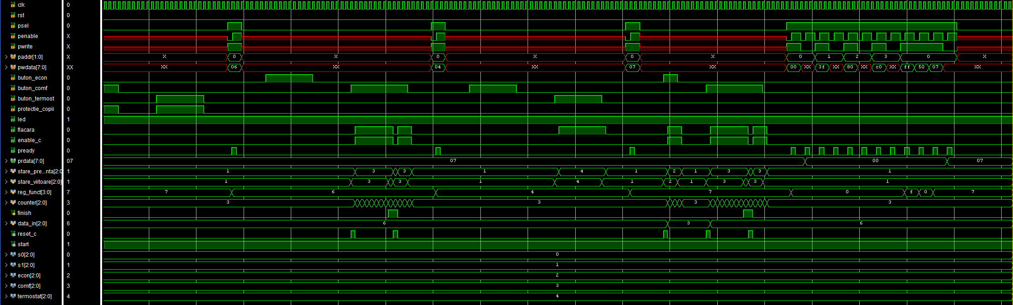

Figure 2. Simulation of the First Version of the DUT in Vivado

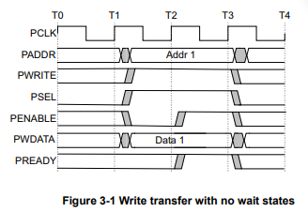

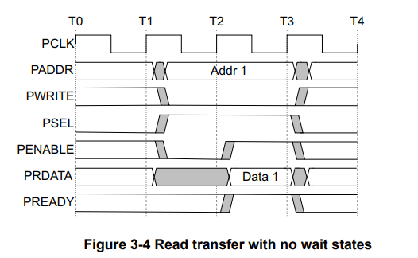

Figures 3, 4. Waveforms for APB Transfer

Register Table
Table 4. Register Table Accessible by the DUT
Register Name | Access Address | Register Structure | Register Field Description
CFG | 0x00 | 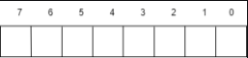 | bit0- ECON_MODE — enables economy mode  bit1- COMF_MODE — enables comfort mode  bit2- TERMOST_MODE — enables thermostat mode  bit3- RESERVED: not used in current implementation  bit 4:7- DON’T CARE(RESERVED)

Verification of the Digital Circuit Design
Verification Environment Architecture
Checklist of Elements to Verify
Functional Coverage Elements
Tests
Obtained Results

Verification Environment Architecture
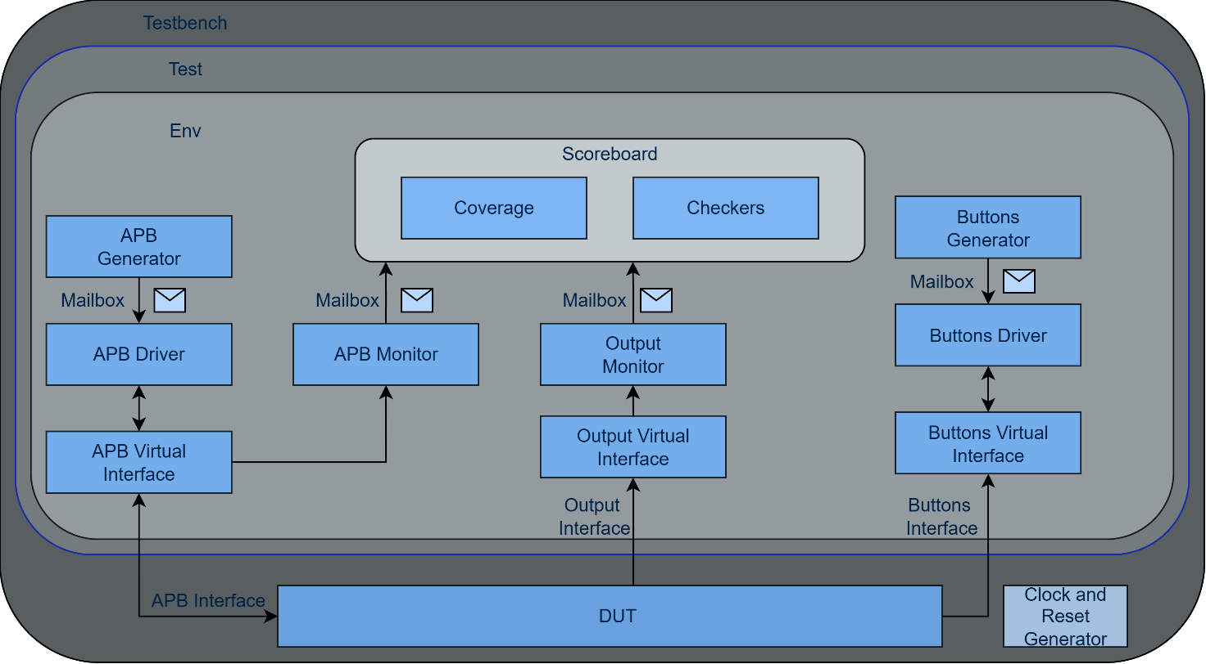
Figure 3. Overview of the components necessary for sending stimuli to the DUT via the APB interface

Driver for Button Interface
The Buttons Driver receives button transactions from the mailbox shared with the Buttons Generator. For each transaction, it waits for the specified delay (in clock cycles), then asserts the corresponding button signals (button_mod_econ, button_mod_comf, button_mod_thermo, button_child_prot) on the buttons interface. The signals are held for a configurable number of clock cycles (the hold field), after which all buttons are deasserted. This level-sensitive behavior matches the DUT’s requirement that buttons must be held for multiple cycles to allow state transitions and counter operation.

APB Driver
The APB Driver receives transactions from the APB Generator via a mailbox. It drives the APB protocol signals (paddr, pwrite, psel, penable, pwdata) on the APB interface following the standard APB handshake: setup phase (psel=1, penable=0), followed by access phase (penable=1), waiting for pready acknowledgment from the DUT. It supports both write and read operations.APB Monitor

Output Interface Monitor
The Output Monitor continuously observes the flame signal (flame_on) on the output interface.
Each clock cycle, it captures the signal value into an output_transaction, sends it to the scoreboard mailbox, and samples the output coverage collector.

APB Interface Transaction
This class contains attributes marked as "rand," meaning they will receive random values.
Used to represent APB transactions in simulations.

Output Interface Transaction
The Output Transaction class contains a single random field: unit_on (boiler active), representing the flame signal state (1 = flame on, 0 = flame off). It is used by the Output Monitor to capture the current state of the DUT’s flame output each clock cycle. The transaction also includes a do_copy() method for deep copying.

Functional Coverage Elements
Table 5. APB Coverage Group (apb_transaction_cg):
Cover Point | Description
pwrite_cp | Write/read transaction types
paddr_cp | All 4 register addresses (0–3)
data_cp | Data value ranges: 4 equal bins [0:255], plus bins for 0x00 and 0xFF
Table 6. APB Coverage Group (apb_transaction_cg):
Cover Point | Description
unit_on_cp | Flame signal states (0=off, 1=on)

Table 7. Buttons Coverage Group (transaction_cg):
Cover Point | Description
button_mod_econ_cp | Economy button states (0 and 1)
button_mod_comf_cp | Comfort button states (0 and 1)
button_mod_thermo_cp | Thermostat button states (0 and 1)
button_child_prot_cp | Child protection button states (0 and 1)

Tests
Table 5. List of Implemented Tests for DUT Verification
Test File Name | Test Description
all_modes_test.sv | Comprehensive directed test: exercises all 3 operating modes (econ/comf/thermo), child protection blocking, register-based mode enable/disable, mode transitions, and full APB address/data coverage sweep.
onebutton_test.sv | Random single-button test: generates random button presses with child protection disabled, verifying FSM transitions.
random_test.sv | Basic random test: generates random button transactions after configuring func_reg.

Obtained Results
After running all_modes_test.sv, the following coverage results were obtained:
- APB Interface: paddr = 100%, data = 100%, pwrite = 100%
- Output Interface: flame = 100%
- Buttons Interface: econ = 100%, comf = 100%, thermo = 100%, child_prot = 100%
All 10 directed tests passed, verifying: economy mode (counter target=3), comfort mode (counter target=6), thermostat mode (no counter), child protection blocking on all 3 modes, register-based mode disable, and mode-to-mode transitions.

